Name : Alif Fauzia Rama Wahyu K.

Class : X

NIM :L200183177

**Practice 1**

1. Make a circuit of image and edit the everything properties of component as showed of table.

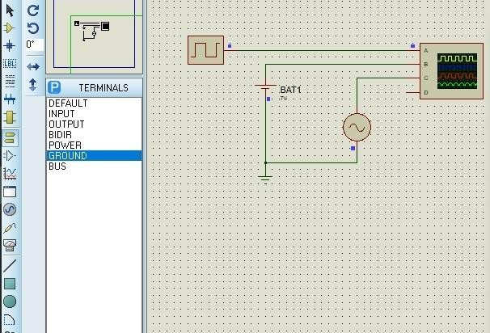

Table 1. component of circuit

|  |  |  |
| --- | --- | --- |
| No | Device | Information |
| 1 | Alternator | V = 5 Volt, f = 100 Hz |
| 2 | Cell | V = 5 Volt |
| 3 | Clock | F = 100 Hz |
| 4 | Ground | Pick from Terminals |
| 5 | Osiloskop | Pick from Instrument |

1. The simulation will show to us a signal line from batre,clock and alternator.

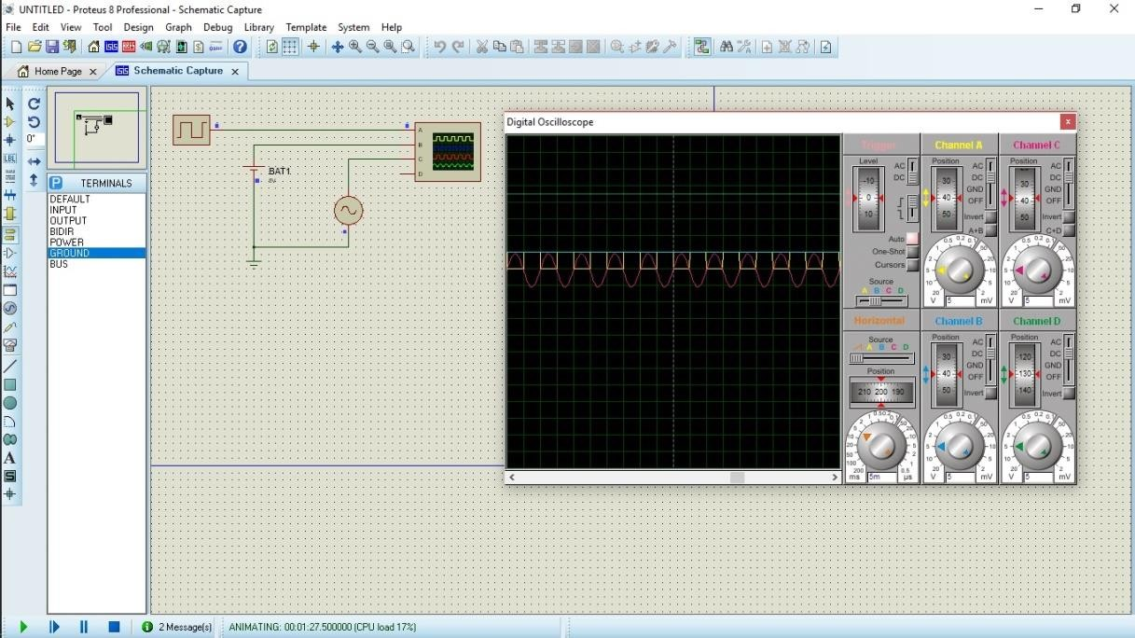

And explain it !

→Channel A is ***clock,*** the shapeof channel A is square.it is analog signal. Channel B is ***Cell,*** the shape of channel B is line,it is digital signal. Channel C is Alternator,the shape of channel C is warped,it is analog signal. The channel D is nothing.

1. Turn off that simulation ! then edit your component as table 2.

Table 2. Propertiese component

|  |  |  |
| --- | --- | --- |
| No | Device | Information |
| 1 | Alternator | V = 10 Volt, f = 50 Hz |
| 2 | Cell | V = 7 Volt |
| 3 | Clock | F = 200 Hz |